Parent/Family Engagement Initiatives

Cultural

Differences

Social & Emotional Needs

School Faculty Staff Volunteers

Niagara Street Elementary School

Social Media

The Importance of Collaboration

**The Whole Child**

Pre-K to High School

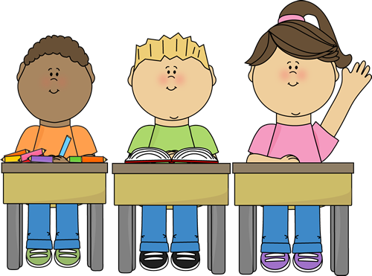

Community Business Schools Partnership

Curriculum connected to real world experiences

School Leadership

Faith-based Organizations

Attendance Academic Behavior

Family

Friends

Neighbors Environment

t

Medical Profession

Health Services

Training all stakeholders

“Parents, families, educators and communities – there’s no better partnership to assure that all students Pre-K to high school have the support and resources they need to succeed in school and life” – NEA Past President Dennis Van Roekel